Task 1: OSI 7-Layer Model

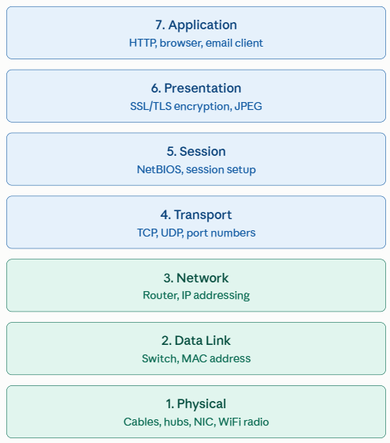

Task 2: Match the Scenarios

- Encrypting data before sending: Presentation Layer (Layer 6)
- Routing packets across networks: Network Layer (Layer 3)
- Converting data to electrical signals: Physical Layer (Layer 1)
- Opening a web page in your browser: Application Layer (Layer 7)
- Detecting and correcting errors in frames: Data Link Layer (Layer 2)

Task 3: App Data Flow Across OSI Layers (WhatsApp)

- Layer 7 (Application Layer): When you type a text message and hit send, the WhatsApp interface uses application-level protocols to structure the chat data and manage message delivery receipts (ticks).
- Layer 6 (Presentation): The message gets end-to-end encrypted (Signal protocol) before it leaves your device, so only the recipient can read it.
- Layer 5 (Session): Establishes and maintains a continuous connection with WhatsApp's server so messages can flow back and forth without reconnecting for each one.
- Layer 4 (Transport Layer): The encrypted message payload is segmented and assigned TCP port numbers, establishing a reliable, connection-oriented session with the WhatsApp server to guarantee that no packets are dropped in transit.
- Layer 3 (Network): Each segment gets wrapped with source/destination IP addresses so it can be routed across the internet to the recipient's device.
- Layer 2 (Data Link Layer): Wi-Fi or mobile network handles communication between my device and the local network.
- Layer 1 (Physical): Underneath it all, the data is converted into radio signals (WiFi) or cellular signals to actually travel over the air.

Task 4: Ping Works, but Website Inaccessible

Identified Layers: Layer 7 (Application Layer) and/or Layer 4 (Transport Layer)
- Why Ping Works: A successful ping utilizes the ICMP (Internet Control Message Protocol), which operates at Layer 3 (Network Layer) alongside IP. This proves that Layers 1, 2, and 3 are functioning properly: the physical cables/wireless links are up, IP addressing is valid, and intermediate routers can find the target machine.
- Why the Website Fails:
- Application Layer (Layer 7): The remote web server daemon (e.g., Nginx, Apache) may be stopped, crashed, misconfigured (500 Internal Server Error), or the local machine may be experiencing a DNS resolution failure if browsing by domain name.
- Transport Layer (Layer 4): A firewall or Access Control List (ACL) along the path or on the host may be allowing ICMP traffic through while actively blocking TCP port 80 (HTTP) or port 443 (HTTPS), preventing the required TCP three-way handshake from completing.

